|  |  |  |  |  |
| --- | --- | --- | --- | --- |
|  | |  | | |
| Nombre del Maestro(a): | Calificación: _____________________ | | | |
| Ing. Irma Irene García Razcón | |  |  |  |
| Nombre de Alumno(a): Victor Manuel Galvan Covarrubias | |  | Fecha: |  |

02 Junio 2021

**1. - Explain correctly what is requested. Value 10 points**

1. Explain what data storage is:

R.- It is the collection of bytes or “data” that are a fundamental part of technological systems for their correct operation.

2. Explain what cloud storage is:

R.- It is online storage and transmission of data on the Internet that are a fundamental part of technological systems. These are usually said to be stored in the cloud. Actually being stored in data centers distributed around the world.

3. Explain what data processing is:

R.- It is when the data collected from the computer systems are transformed or translated into usable information, this to later provide clear and precise results without affecting our system.

4. Explain what MongoDB is, include advantages and disadvantages:

R.- It is a database distributed in the cloud, based on documents and collections of general use. For the development of modern applications and systems that require great scalability and easy access.

Advantage:

* Ideal for low-resource environments.
* Very low costs.
* Much documentation available.

Disadvantages:

* Doesn't handle transactions well.
* It is of an early age.
* Collections cannot be related.

5. - Explain what MySQL is, include advantages and disadvantages.

R.- It is used to store data in relational databases, as well as to manage them without complexity thanks to the visual interface and all the options and tools available.

Advantage:

* Free use and no payment required.
* Speed to perform operations.
* Ease of installation and configuration.
* Implementation of joins, stored procedures, triggers and transaction management.

Disadvantages:

* The documentation is not official.
* It is not that intuitive.
* It is not effective as long as constant modification is required.

**2.- Match the type of storage device to which it corresponds with a line. Value 12 points**

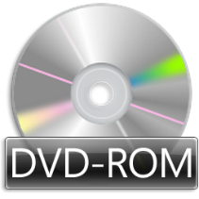

1. - Primary Storage-

2. - Diskettes

3. - Secondary Storage

4. - Flash memory devices

5. - Cloud storage.

6. - Optical storage devices.

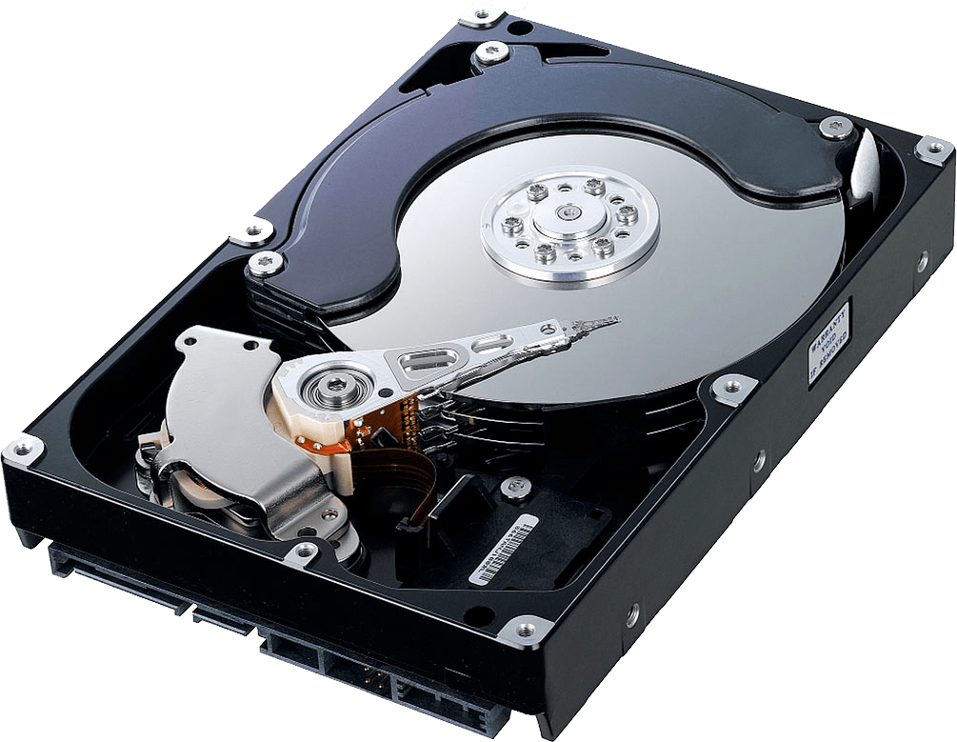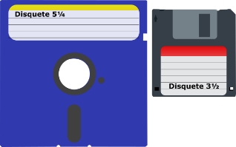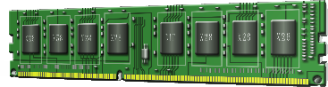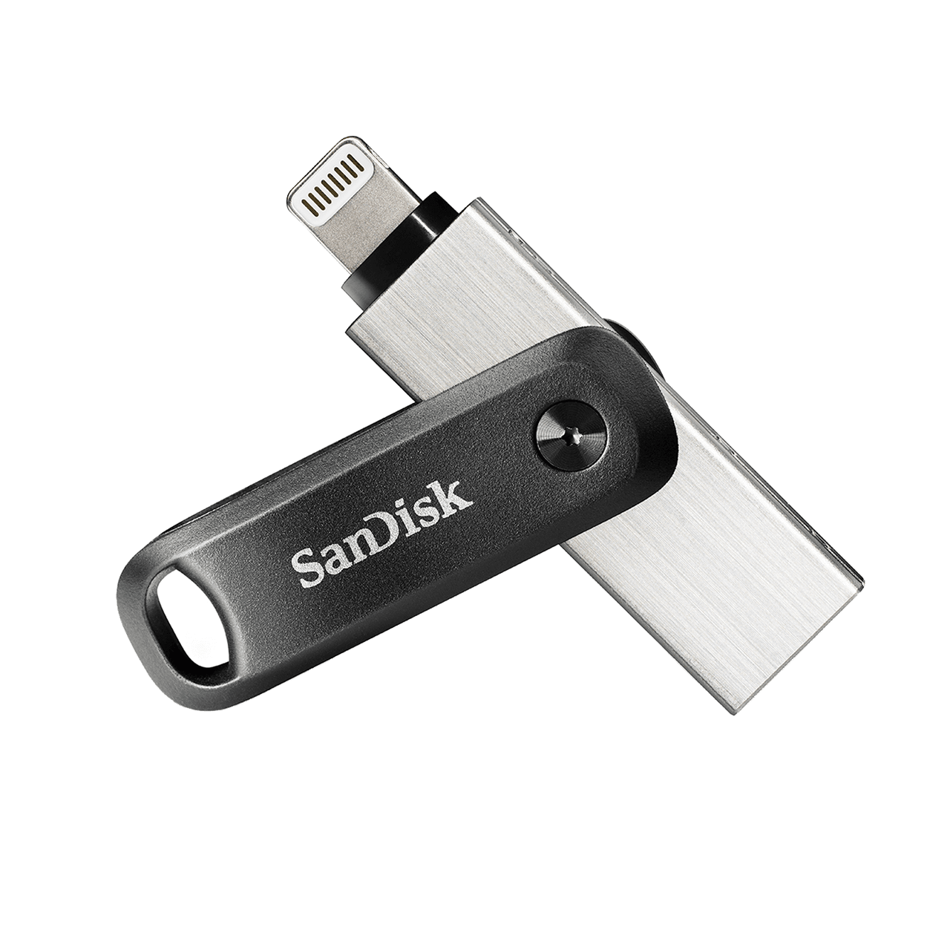

**3. - Answer correctly. Value 8 points**

1. - What is it, what is it for and where can we apply a HC-SR04 sensor?

R.- It is a sensor that measures distance from an object based on the rebound of a sound wave that it emits, working within the range in which we cannot perceive it.

Its applications can be:

* Automatic parking lots.
* Product filling.
* Systems for the prevention of collisions.
* Security systems.

2. - What is it, what is it for and where can we apply a DHT11 sensor?

R.-It is a sensor implemented in IOT systems for the measurement of humidity and temperature.

Its applications can be:

* Greenhouse control.
* Air conditioning.
* Weather measurement

3. - What is it, what is it for and where can we apply a switch (pushbutton)?

R.-It is an electronic component which when exerting pressure on it produces any effect determined by the manufacturer.

Its applications can be:

* Industrial systems.
* Home systems.
* IOT systems.

In general, a pushbutton can be implemented in most electronic and electrical systems.